

Minutes of Monthly Meeting of Longford County Council
held in the Council Chamber, Aras an Chontae, Great Water Street, Longford on
Wednesday, 12th September 2018 at 4.00 p.m.
____________________________________________________________________

PRESIDING: Councillor Luie McEntire, Cathaoirleach.

MEMBERS PRESENT: Councillors – Paraic Brady, John Browne, Seamus Butler, Mick Cahill, Micheál Carrigy, Mark Casey, Gerard Farrell,
Joe Flaherty, Martin Mulleady, Colm Murray, Peggy Nolan, Pat O’Toole, Paul Ross, Mae Sexton and Gerry Warnock.

APOLOGIES: Councillors - Gerard Hagan and P.J. Reilly.

IN ATTENDANCE: Mr. Paddy Mahon, Chief Executive.
Mr. John McKeon, Head of Finance.
Mr. Declan Kilcline, Acting Director of Services.

ACTING MEETINGS
ADMINISTRATOR: Ms. Mary Cooney.

VOTE OF SYMPATHY.

On the proposal of Councillor G. Warnock seconded by Councillor S. Butler, it was unanimously resolved that a vote of sympathy be extended to Councillor Mark Casey on the death of his wife Bernadette. Sincere sympathy was also extended to their children, Brian, Cormac and Niamh, mother-in-law Mae, and to all of their family and extended families.

All members of the Council associated themselves with the vote of sympathy and many tributes were paid to the late Bernadette. The members assured Mark of their support and their prayers for the family during this very difficult time.

Mr. Paddy Mahon, Chief Executive, on his own behalf and on behalf of the staff of the County Council, also associated himself with the vote of sympathy.

Councillor Casey thanked the members for their sympathy and support.

A silent prayer was said for the deceased.

It was agreed that the Adjourned Meeting take place on Tuesday, 18th September 2018
at 4.00 p.m.

NOTICE OF MOTION

The following Notice of Motion was proposed by the Cathaoirleach, Councillor L. McEntire and seconded by Councillor S. Butler.

“That a Special Meeting of the Council be held to consider whether Longford County Council will propose a resolution to nominate a person to be a candidate at the Presidential Election 2018, in accordance with Section 16 (i) of the Presidential Election Act 1993".

It was agreed that a Special Meeting be held on Tuesday 18th September at 11.00 a.m.

This concluded the business of the meeting.
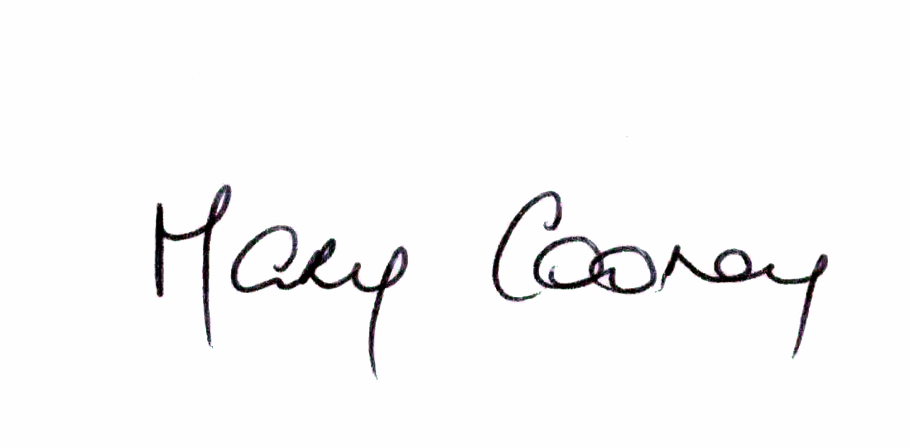

Signed: _______________
Mary Cooney,
Acting Meetings Administrator.

Confirmed and adopted at Monthly Meeting of Longford County Council held on the
10th October 2018.

Signed: _______________
Cathaoirleach.

